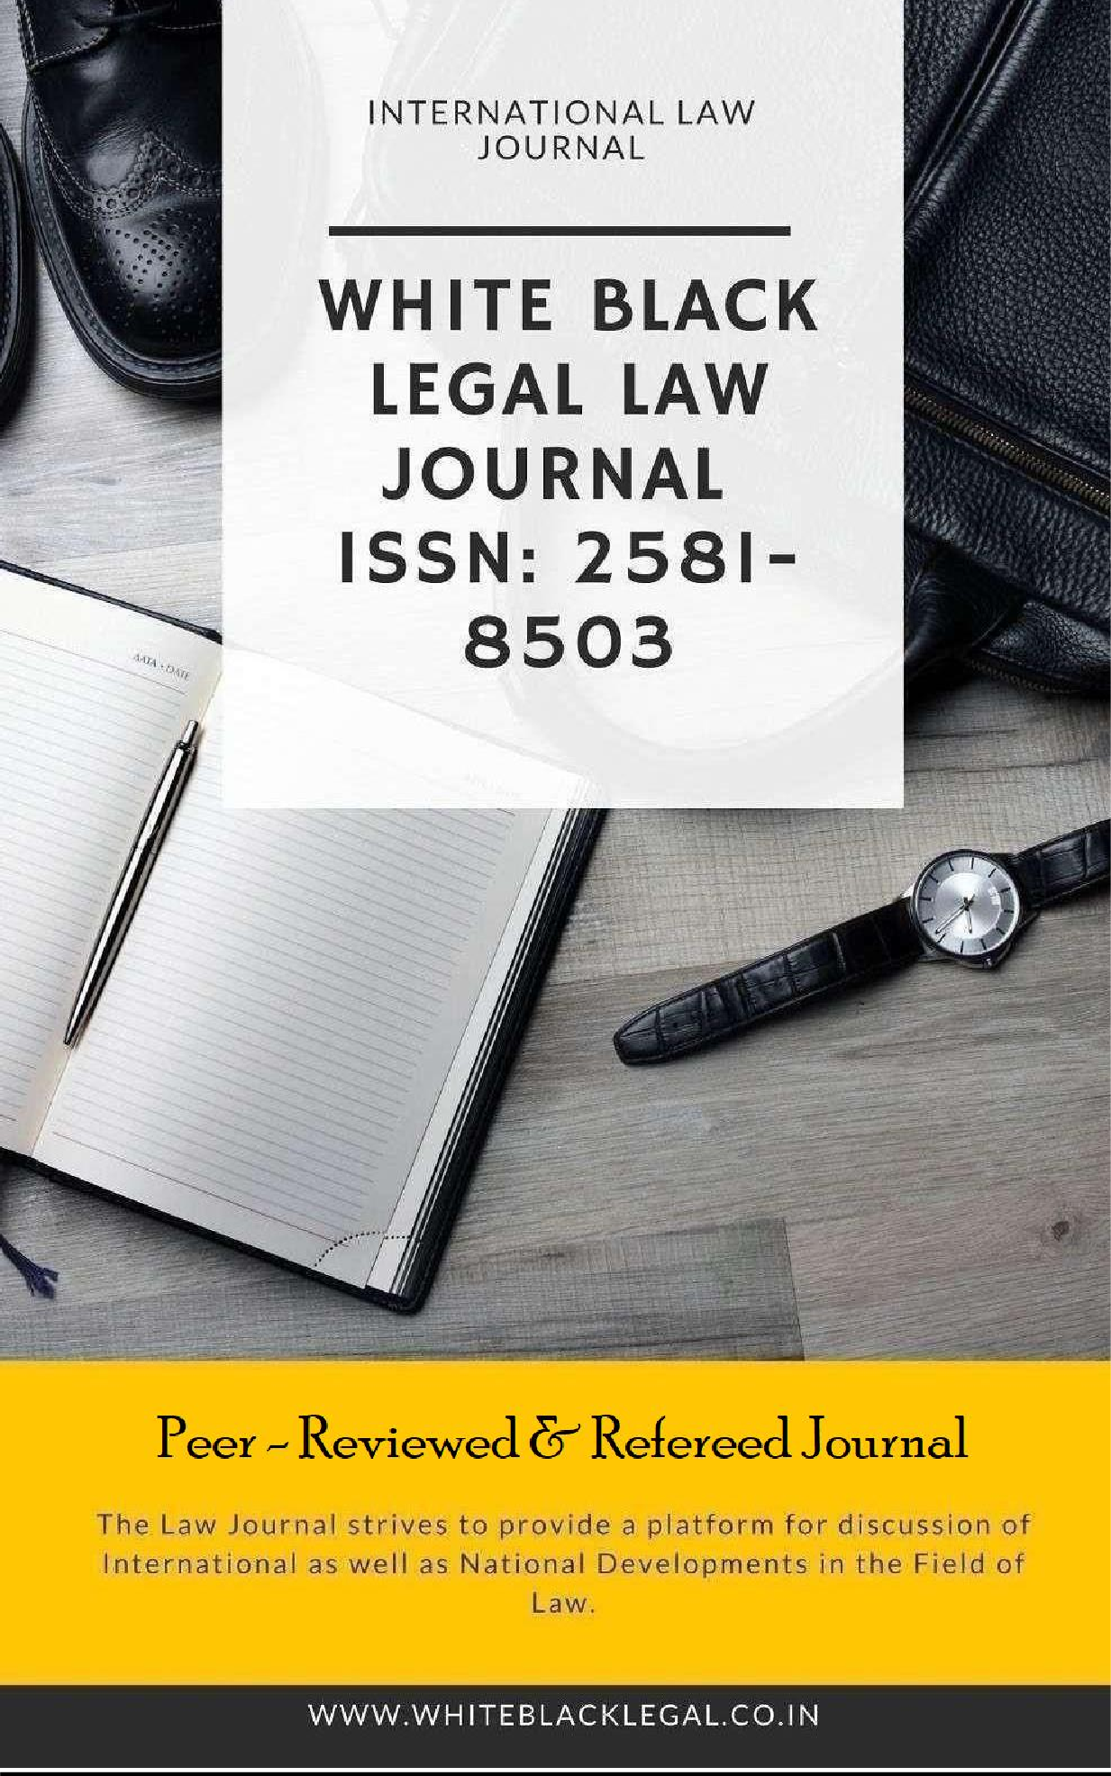

DISCLAIMER

No part of this publication may be reproduced or copied in any form by any means without prior written permission of Editor-in-chief of White Black Legal – The Law Journal. The Editorial Team of White Black Legal holds the copyright to all articles contributed to this publication. The views expressed in this publication are purely personal opinions of the authors and do not reflect the views of the Editorial Team of White Black Legal. Though all efforts are made to ensure the accuracy and correctness of the information published, White Black Legal shall not be responsible for any errors caused due to oversight or otherwise.

EDITORIAL TEAM

Raju Narayana Swamy (IAS ) Indian Administrative Service officer
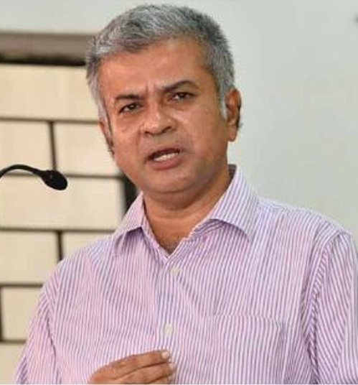
Dr. Raju Narayana Swamy popularly known as Kerala's Anti Corruption Crusader is the
All India Topper of the 1991 batch of the IAS and is currently posted as Principal
Secretary to the Government of Kerala . He has earned many accolades as he hit against
the political-bureaucrat corruption nexus in India. Dr Swamy holds a B.Tech in Computer
Science and Engineering from the IIT Madras and a Ph. D. in Cyber Law from Gujarat
National Law University . He also has an LLM (Pro) ( with specialization in IPR) as well
as three PG Diplomas from the National Law University, Delhi- one in Urban
Environmental Management and Law, another in Environmental Law and Policy and a
third one in Tourism and Environmental Law. He also holds a post-graduate diploma in
IPR from the National Law School, Bengaluru and a professional diploma in Public
Procurement from the World Bank.


Dr. R. K. Upadhyay

Dr. R. K. Upadhyay is Registrar, University of Kota (Raj.), Dr Upadhyay obtained LLB , LLM degrees from Banaras Hindu University & Phd from university of Kota.He has succesfully completed UGC sponsored M.R.P for the work in the ares of the various prisoners reforms in the state of the Rajasthan.

Senior Editor


Dr. Neha Mishra

Dr. Neha Mishra is Associate Professor & Associate Dean (Scholarships) in Jindal Global Law School, OP Jindal Global University. She was awarded both her PhD degree and Associate Professor & Associate Dean M.A.; LL.B. (University of Delhi); LL.M.; Ph.D. (NLSIU, Bangalore) LLM from National Law School of India University, Bengaluru; she did her LL.B. from Faculty of Law, Delhi University as well as M.A. and B.A. from Hindu College and DCAC from DU respectively. Neha has been a Visiting Fellow, School of Social Work, Michigan State University, 2016 and invited speaker Panelist at Global Conference, Whitney R. Harris World Law Institute, Washington University in St.Louis, 2015.


Ms. Sumiti Ahuja
Ms. Sumiti Ahuja, Assistant Professor, Faculty of Law, University of Delhi,
Ms. Sumiti Ahuja completed her LL.M. from the Indian Law Institute with specialization in Criminal Law and Corporate Law, and has over nine years of teaching experience. She has done her LL.B. from the Faculty of Law, University of Delhi. She is currently pursuing Ph.D. in the area of Forensics and Law. Prior to joining the teaching profession, she has worked as Research Assistant for projects funded by different agencies of Govt. of India. She has developed various audio-video teaching modules under UGC e-PG Pathshala programme in the area of Criminology, under the aegis of an MHRD Project. Her areas of interest are Criminal Law, Law of Evidence, Interpretation of Statutes, and Clinical Legal Education.


Dr. Navtika Singh Nautiyal

Dr. Navtika Singh Nautiyal presently working as an Assistant Professor in School of law, Forensic Justice and Policy studies at National Forensic Sciences University, Gandhinagar, Gujarat. She has 9 years of Teaching and Research Experience. She has completed her Philosophy of Doctorate in ‘Intercountry adoption laws from Uttranchal University, Dehradun’ and LLM from Indian Law Institute, New Delhi.


Dr. Rinu Saraswat

Associate Professor at School of Law, Apex University, Jaipur,
M.A, LL.M, Ph.D,
Dr. Rinu have 5 yrs of teaching experience in renowned institutions like Jagannath University and Apex University.
Participated in more than 20 national and international seminars and conferences and 5 workshops and training programmes.


Dr. Nitesh Saraswat

E.MBA, LL.M, Ph.D, PGDSAPM
Currently working as Assistant Professor at Law Centre II, Faculty of Law, University of Delhi. Dr. Nitesh have 14 years of Teaching, Administrative and research experience in Renowned Institutions like Amity University, Tata Institute of Social Sciences, Jai Narain Vyas University Jodhpur, Jagannath University and Nirma University.
More than 25 Publications in renowned National and International Journals and has authored a Text book on Cr.P.C and Juvenile Delinquency law.


Subhrajit Chanda

BBA. LL.B. (Hons.) (Amity University, Rajasthan); LL. M. (UPES, Dehradun) (Nottingham Trent University, UK); Ph.D. Candidate (G.D. Goenka University)
Subhrajit did his LL.M. in Sports Law, from Nottingham Trent University of United Kingdoms, with international scholarship provided by university; he has also completed another LL.M. in Energy Law from University of Petroleum and Energy Studies, India. He did his B.B.A.LL.B. (Hons.) focussing on International Trade Law.

ABOUT US

WHITE BLACK LEGAL is an open access, peer-reviewed and
refereed journal providededicated to express views on topical legal issues, thereby generating a cross current of ideas on emerging matters. This platform shall also ignite the initiative and desire of young law students to contribute in the field of law. The erudite response of legal luminaries shall be solicited to enable readers to explore challenges that lie before law makers, lawyers and the society at large, in the event of the ever changing social, economic and technological scenario.
With this thought, we hereby present to you

DIGITAL MEDIA AND COPYRIGHT LAW: BALANCING INFRINGEMENT AND USER RIGHTS

AUTHORED BY – APOORWA SHARMA
Assistant Professor (Law)
Government Law College (Churu)

ABSTRACT:
Copyright protection has grown in importance in the digital age for publishers, users, and content producers. The difficulties in enforcing copyright in the digital era are examined in this article, along with the ease of distribution and replication, tracking difficulties, ownership complexity, and high enforcement costs. Additionally, it offers solutions to these problems, such as copyright education, watermarking, digital rights management, and legal action. The proliferation of digital technology has made copyrighted content simpler to access, duplicate, and distribute than in the past. But this accessibility has also made it harder to uphold intellectual property rights and police copyright regulations. We shall examine the difficulties with copyright protection in the digital era in the following article.
Studying the confluence of " Digital Media and Copyright Law: Balancing Infringement and User Rights " has a number of important goals that are all interconnected. Its primary goal is to provide an understanding of the relationship between copyright law and the fluidity of communication platforms. In this context, it will be investigated how traditional copyright laws relate to the production, distribution, and use of information on social media platforms, where user-generated content frequently obfuscates the distinctions between originality and ownership. The second goal of the study is to pinpoint and comprehend the copyright infringement issues that social media platforms face.
KEYWORDS: Copyright Law, Intellectual Property Rights, Data Privacy, India, Online Ecosystem, Digital Technologies, Creative Works, Intellectual Property Protection, Data Privacy Rights, Digital Age, Historical Background, Traditional Copyright Principles

INTRODUCTION
In the digital age, the intersection of copyright law and digital media has become increasingly complex, posing new challenges for legal experts. As technology continues to evolve, the delicate balance between protecting intellectual property and safeguarding user rights has become a focal point of legal discussions and policymaking. My research paper delves into this intricate landscape, examining the challenges and opportunities for balancing infringement and user rights in the realm of digital media and copyright law. Copyright protection has grown in importance in the digital age for publishers, users, and content producers. It has become more challenging to stop copyright violations and piracy due to the ease of dissemination and replication of digital information. Furthermore, determining ownership and upholding copyright regulations may be difficult and expensive tasks. In order to tackle these issues, strategies including watermarking, copyright education, digital rights management, and litigation

One of the primary issues at the heart of this discussion is the ease of digital content replication and distribution. The advent of the internet and digital technologies has significantly amplified the speed and scale at which copyrighted material can be reproduced and disseminated. This has, in turn, heightened concerns regarding copyright infringement and piracy. Legal experts are tasked with navigating this terrain, aiming to uphold the rights of content creators and copyright holders while also ensuring that users' rights to access and engage with digital media are respected.

Moreover, the concept of fair use adds another layer of complexity to this landscape. Fair use provisions enable the limited use of copyrighted material without the need for permission from the copyright owner, particularly for purposes such as commentary, criticism, news reporting, and scholarly works. However, determining what constitutes fair use in the context of digital media can be intricate, as the boundaries between transformative use and infringement are not always clear-cut. Legal experts are challenged with interpreting and applying fair use principles to digital content in a manner that balances the interests of both rights holders and users. Additionally, the emergence of user-generated content platforms and social media further complicates the legal considerations surrounding digital media and copyright law. These platforms enable users to create and share a vast array of content, blurring the lines between personal expression, creative production, and copyright infringement. As such, legal experts are confronted with the task of delineating the rights and responsibilities of platform users, content creators, and platform operators within this dynamic ecosystem.

To address these complexities, legal experts are exploring innovative approaches to copyright law in the digital sphere. Concepts such as digital rights management (DRM) and technological protection measures (TPMs) have been advanced to safeguard copyrighted material from unauthorized use and distribution. However, these measures raise important questions about their potential impact on users' ability to engage with digital media in permissible ways, prompting legal experts to critically assess the implications of such strategies on the balance between infringement and user rights. Furthermore, the rise of open access and open licensing models presents an alternative paradigm for managing digital media and copyright. By embracing principles of openness and collaboration, these models aim to expand access to knowledge and creative works while still upholding the principles of attribution and integrity. Legal experts are actively exploring the implications of these models within the framework of copyright law, evaluating their potential to harmonize the interests of rights holders and users in the digital era.

KEY TERMS AND THEIR MEANINGS:
A legal privilege known as copyright is bestowed upon the authors of original works of authorship, such as computer programs, images, and other creative expressions, in addition to literary, artistic, musical, and dramatic works. Copyright law gives the owner of the copyright the only authority to manage how their work is reproduced, distributed, and displayed in public. It also gives them the freedom to make unique works that are derivative of their originals.
The phrase "digital era" describes a time when digital technologies—like computers, the internet, and mobile devices—have proliferated and profoundly changed how we interact with one another, do business, and live our lives.

CHALLENGES OF COPYRIGHT PROTECTION IN THE DIGITAL AGE
The protection of copyright has faced several difficulties in the digital age. Among the principal difficulties are:
- Simple Reproduction and Distribution: With the development of digital technology, copyrighted content is now much more easily reproduced and distributed. It only takes a few seconds to create and distribute digital versions of books, music, and movies to people all over the world.

- Tracking: It can be challenging to monitor the usage of protected works in the digital era. When a digital copy is made available for download on the internet, it can be shared and downloaded several times, making it nearly impossible to track who is utilizing the content and why.
- Ownership of Complexes: It can be challenging to prove ownership of copyrighted content in the digital era. It might be challenging to identify the original creator of a certain work or the person with the authority to disseminate it due to the ease of copying and dissemination.
- High Cost of Enforcement: In the digital era, upholding copyright rules may be an expensive and time-consuming procedure. It can be challenging to spot instances of copyright infringement and bring legal action against individuals at fault given the abundance of content available online.
- International Scope: With the widespread distribution of information in the digital era, copyright rules may be challenging to uphold in many nations with various legal frameworks.
- Fair Use: Copyrighted content may be used in limited ways without a copyright owner's consent according to the idea of fair use. But figuring out what is fair use may be a subjective and involved process, which can make copyright rules hard to execute.
- User-Generated material: People may now produce and distribute their own material more easily than ever thanks to the growth of social media and other platforms that support user-generated content. On the other hand, this can also make it challenging to enforce copyright rules and identify the owner of the copyright to a certain work.
- Emerging Technologies: The creation, distribution, and consumption of information are all undergoing continual change as a result of emerging technologies like blockchain and artificial intelligence. It might be difficult to stay on top of these new technologies and their possible effects on copyright protection.
- Access and Protection: While copyright protection is crucial, it's also critical to strike a balance between the protection of intellectual property and the demands of free speech and access to information. In the digital era, striking the correct balance between protection and access may be difficult.

Solutions to Address Challenges of Copyright Protection in the Digital Age
Copyright protection is a critical issue in the digital age, as the ease of sharing and replicating digital content has raised significant challenges for legal experts. However, there are several solutions that can address these challenges and ensure the protection of intellectual property rights in the digital realm.
One of the key solutions to the challenges of copyright protection in the digital age is the advancement of technological tools. Digital watermarking, content recognition technologies, and blockchain-based solutions have emerged as powerful tools to track and protect digital content. These technologies enable legal experts to trace the source of unauthorized distribution and take necessary legal actions to protect copyright.

Another important solution is the development and implementation of international treaties and agreements to harmonize copyright laws across different jurisdictions. This ensures that legal experts have a standardized framework to address copyright issues on a global scale, making it easier to enforce copyright protection across borders and jurisdictions. Furthermore, strengthening enforcement mechanisms is crucial in addressing the challenges of copyright protection. This involves increasing the resources and capabilities of law enforcement agencies to tackle online piracy and copyright infringement. Collaboration between legal experts, law enforcement agencies, and technology companies can enhance the ability to identify and prosecute entities involved in digital copyright violations.
Education and awareness programs also play a significant role in addressing copyright protection challenges. Legal experts can actively engage in educating content creators, consumers, and businesses about the importance of respecting copyright laws and the potential consequences of copyright infringement. By promoting a culture of respect for intellectual property rights, legal experts can contribute to reducing copyright violations in the digital space. Additionally, the development of effective digital rights management (DRM) systems is crucial for safeguarding copyrighted digital content. DRM technologies enable legal experts to control and manage the use of digital content, preventing unauthorized access, distribution, and reproduction. Implementing DRM solutions can significantly enhance the protection of copyrighted works in the digital environment.
- Digital Rights Management (DRM): DRM is a technology that restricts access to digital content and prevents unauthorized copying and distribution. It can be used to protect copyrighted materials, such as music, movies, and eBooks, from piracy.
- Watermarking: Watermarking is a process of embedding a unique identifier into digital content, such as images or videos. It can be used to track and identify the source of content and to deter unauthorized use.
- Copyright Education: Educating users about copyright laws and the consequences of copyright infringement can help to reduce the incidence of piracy and encourage responsible use of copyrighted materials.
- International Collaboration: Collaboration between governments, industry, and international organizations can help to develop and enforce consistent copyright laws across different countries and legal systems.
- Creative Commons Licensing: Creative Commons is a non-profit organization that provides a range of free, standardized licenses that creators can use to grant permission for others to use their copyrighted materials. These licenses allow creators to retain ownership of their content while enabling others to use it in a variety of ways, depending on the terms of the license.
- Blockchain Technology: Blockchain is a decentralized digital ledger that can be used to track ownership and usage of digital content. By using blockchain technology, copyright owners can create an immutable record of their ownership and control the distribution and usage of their content more effectively.
- Collaborative Content Protection: Collaborative content protection involves bringing together a range of stakeholders, including content creators, publishers, technology providers, and legal experts, to develop and implement effective copyright protection strategies. By working together, these stakeholders can develop more comprehensive and effective solutions that address the challenges of copyright protection in the digital era.
- Fair Use Guidelines: Fair use is a legal concept that allows for the limited use of copyrighted materials without permission from the copyright owner. However, the scope of fair use can be unclear and subjective, and it can vary depending on the jurisdiction and context. Developing clear and comprehensive fair use guidelines can help to promote responsible use of copyrighted materials while respecting the rights of copyright owners.
LEGAL PROVISIONS RELATED TO DIGITAL MEDIA AND COPYRIGHT LAW
The Digital Millennium Copyright Act (DMCA) is a cornerstone of digital media and copyright law. Enacted in 1998, the DMCA criminalizes the production and dissemination of technology, devices, or services intended to circumvent measures that control access to copyrighted works. It also heightens the penalties for copyright infringement on the internet. Legal experts are tasked with keeping abreast of the latest developments and interpretations of the DMCA to ensure compliance for their clients in the digital space. Another essential area of consideration is the issue of licensing and distribution of digital media. The licensing of digital content involves complex agreements that dictate the terms of use, distribution, and compensation for copyrighted works. Legal experts are instrumental in drafting, negotiating, and reviewing these licensing agreements to safeguard the rights of both content creators and distributors. Moreover, with the advent of new digital platforms and distribution models, legal professionals must navigate evolving legal frameworks to address emerging issues such as streaming rights, territorial restrictions, and cross-border distribution.
- The Copyright Act, 1957: The Copyright Act provides legal protection for original literary, artistic, and musical works, including digital content. The act outlines the rights and responsibilities of copyright owners, and provides legal remedies for copyright infringement
- The Information Technology Act, 2000: The IT Act is a comprehensive law that deals with a wide range of cyber-crimes, including copyright infringement. The act outlines penalties for various offenses related to digital content, such as hacking, piracy, and illegal file sharing.
- The Digital Millennium Copyright Act (DMCA): Although the DMCA is a US law, it has been adopted by several countries, including India. The DMCA provides legal protection for digital content, and outlines procedures for filing copyright infringement complaints with internet service providers.
- The Indian Penal Code (IPC): The IPC contains provisions related to copyright infringement, including penalties for offenses such as copying and distributing copyrighted materials without permission.
- The Copyright Rules, 2013: The Copyright Rules provide guidelines for the registration, licensing, and enforcement of copyright in India. The rules outline procedures for registering copyrighted materials, as well as procedures for filing complaints and conducting legal proceedings related to copyright infringement.

These laws and regulations help to provide legal protection for copyright owners and deter piracy and copyright infringement in the digital era. However, enforcement of these laws can be a challenge, and there is a need for continued efforts to raise awareness about copyright laws and promote responsible use of digital content.
NOTABLE COPYRIGHT INFRINGEMENT CASES RELATED TO DIGITAL MEDIA IN INDIA
In recent years, India has witnessed a surge in copyright infringement cases related to digital media. This trend has raised significant legal implications and has garnered the attention of legal experts across the country. we will notify into some of the notable copyright infringement cases that have shaped the legal landscape of digital media in India. One of the landmark cases in India's digital copyright infringement sphere is the dispute between music labels and online platforms. The music industry, represented by prominent labels, has been involved in multiple legal battles against online platforms for unauthorized hosting and distribution of copyrighted music. These cases have set precedents for defining the liabilities of online platforms in copyright infringement scenarios. Furthermore, the emergence of peer-to-peer (P2P) file-sharing networks has posed substantial challenges in enforcing copyright laws. One of the most widely discussed cases involved a popular torrent website that facilitated the dissemination of copyrighted movies and music. The legal complexities surrounding the liability of such platforms and their users have been a subject of extensive debate and litigation. In the realm of digital publishing, a case involving unauthorized reproduction and distribution of e-books sparked significant discourse within legal circles. This case raised pivotal questions about the protection of digital literary works and the enforcement of copyright laws in the rapidly evolving landscape of e-publishing.

Another noteworthy case pertains to the unauthorized streaming of live sporting events over digital platforms. This raised concerns about the infringement of broadcasting rights and the challenges of regulating unauthorized live streaming, especially in the absence of robust digital enforcement mechanisms. The role of social media platforms in copyright infringement has also been a focal point of legal contention. Several cases have emerged where user-generated content on social media platforms has been found to infringe upon copyrighted material. This has led to discussions on the responsibilities of platform operators and the measures that can be implemented to curb copyright violations in user-generated content.
- R.G Anand vs. Deluxe Films and Ors. (1978):
  - Facts of the case:
    - The plaintiff, R.G. Anand, wrote a play titled “Hum Hindustani.”
    - The defendants produced a film with the same title, allegedly infringing on the play’s copyright.
  - Issues involved:
    - Whether the film’s storyline and dialogues were copied from the play.
  - Rule Analysis:
    - The court examined similarities between the play and the film.
    - It concluded that substantial portions were copied, constituting copyright infringement.
  - Conclusion:
    - The court upheld the plaintiff’s copyright and granted an injunction against the film’s release.
- Ratna Sagar Pvt. Ltd. vs. Trisea Publications and Ors. (1996):
  - Facts of the case:
    - Ratna Sagar published educational books.
    - Trisea Publications allegedly copied substantial portions of these books.
  - Issues involved:
    - Whether the copied content constituted infringement.
  - Rule Analysis:
    - The court compared the books and identified verbatim copying.
    - It ruled in favor of Ratna Sagar, emphasizing originality and creativity.
  - Conclusion:
    - The defendant was restrained from further infringement.
- Shree Venkatesh Films Pvt. Ltd. vs. Vipul Amrutlal Shah and Ors. (2009):
  - Facts of the case:
    - Shree Venkatesh Films produced the Bengali film “Chander Bari.”
    - Vipul Amrutlal Shah remade it as the Hindi film “Waqt.”
  - Issue involved:
    - Whether the remake infringed on the original film’s copyright.
  - Rule Analysis:
    - The court analyzed similarities in plot, characters, and scenes.
    - It found substantial copying and ruled in favor of Shree Venkatesh Films.
  - Conclusion:
    - The defendant was restrained from further distribution of the Hindi film.
- Test for copyright infringement:
  - Courts consider substantial similarity, originality, and access to the work.
  - A mere idea cannot be copyrighted; expression matters.
  - Fair use and transformative use are relevant defenses.
- Legal enforcement and remedies:
  - Copyright owners can seek injunctions, damages, and accounts of profits.
  - Technological Protection Measures (TPMs) combat digital infringement.
  - Section 65A penalizes circumvention of TPMs.
- Strategies for copyright protection:
  - Educate users about copyright laws.
  - Use watermarks, DRM, and licensing agreements.
  - Collaborate with legal authorities and industry stakeholders.
CONCLUSION
In conclusion, the intricate interplay between digital media and copyright law presents a multifaceted landscape that demands nuanced consideration from legal experts. Balancing the imperatives of copyright protection with the preservation of user rights in the digital age remains a crucial undertaking, requiring ongoing dialogue, scholarship, and legal innovation to chart a path that fosters a fair and sustainable digital ecosystem for all stakeholders.
The proliferation of digital media has given rise to a multitude of copyright infringement cases in India, significantly impacting the legal landscape. These cases have grappled with complex issues such as the liability of online platforms, enforcement of digital copyright laws, and the protection of intellectual property in the digital domain. As technology continues to evolve, legal experts face the ongoing challenge of interpreting and applying copyright laws to address the intricacies of digital media infringement cases.

